1. Count the total number of employees.

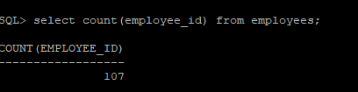

1. Get the average salary of all employees.

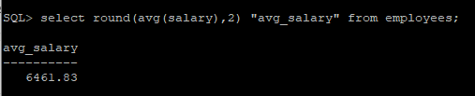

1. 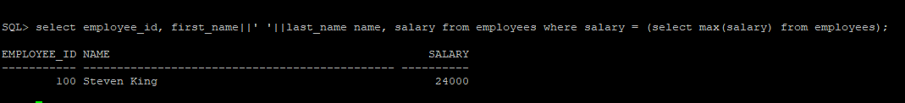Find the maximum salary in the company.
2. 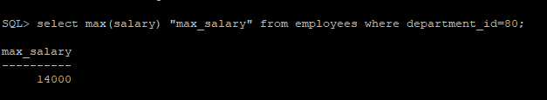Get the minimum salary in department 80.

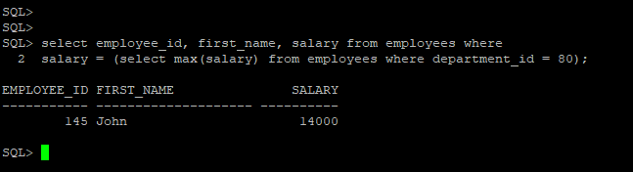

1. Get total salary paid by each departments.

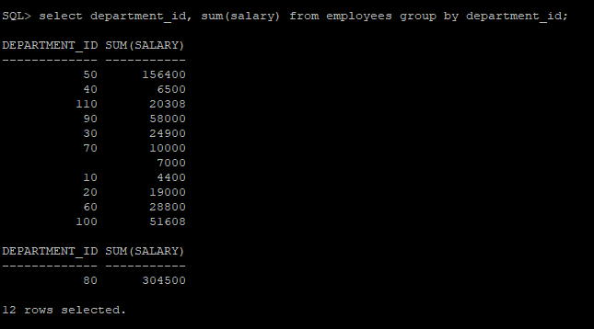

1. 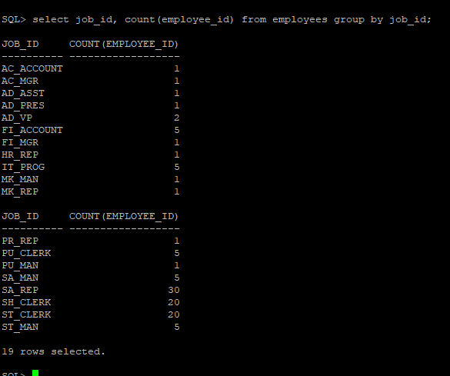Find number of employees per job title.

1. Get average salary per department.

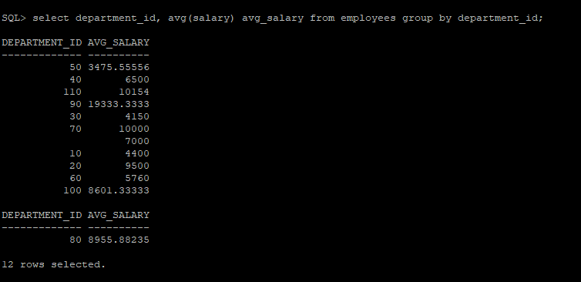

1. Show departments with more than 5 employees.

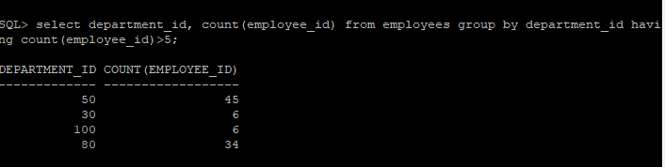

9 Count how many managers exist.

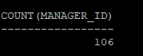

10 Get average commission percentage (excluding NULLs).

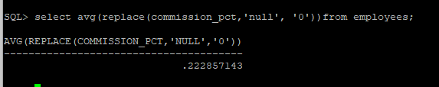

1. Find job ID with highest average salary.

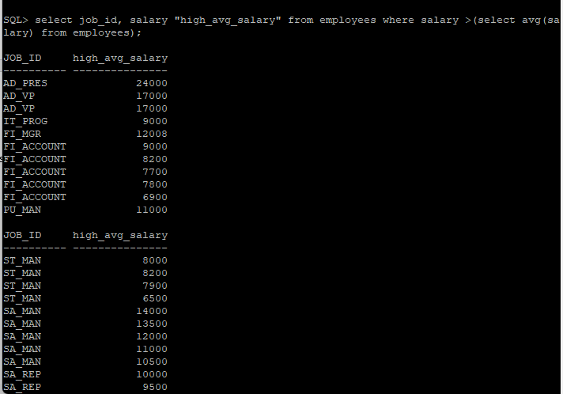

12 Show job IDs with more than 3 employees.

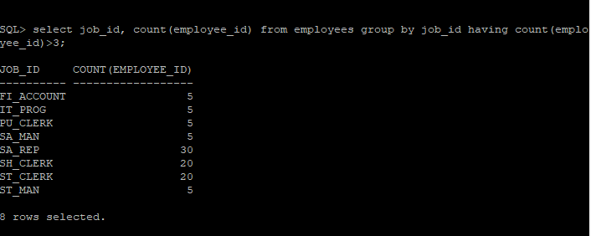

13 Display department-wise minimum and maximum salaries.

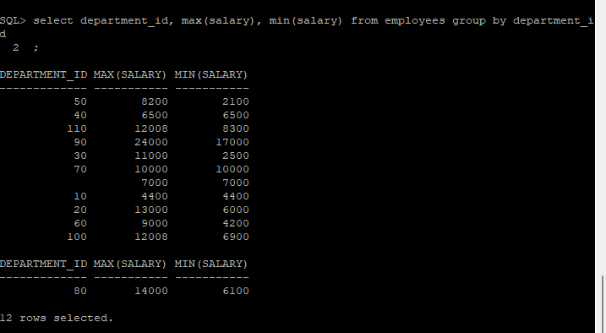

14 List the total number of departments.

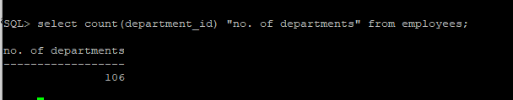

15. Find department with highest total salary

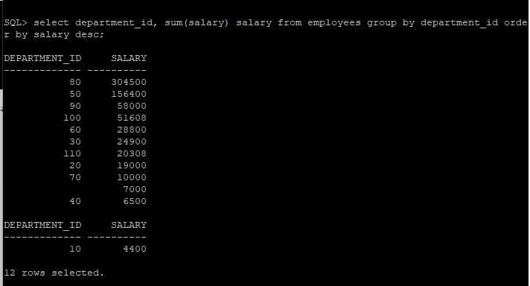

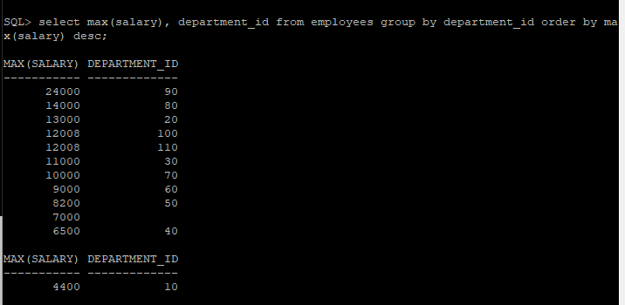

16. Get number of employees hired each year.

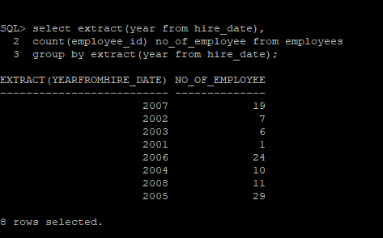

17 List departments where average salary > 5000.

